CHAPTER 1

Drone Hardware Components and Specifications

1.1 Introduction
This chapter provides a detailed description of all the hardware components used in the development of the drone for the project titled “Green Wings: An Innovative
Solution for Erosion Control and Afforestation.”
The project required the design and construction of a custom quadcopter that can provide aerial surveillance and capture real-time video of land conditions. Each hardware component was carefully selected to ensure stability, durability, and efficiency while keeping the overall design lightweight and cost-effective.
The main hardware components used in this drone include the APM 2.8 flight controller, DJI F450 frame, 900KV brushless motors, 40A ESCs, 2200mAh LiPo battery, FlySky FS-i6 transmitter and receiver, ESP32 camera, connectors, holding wires, and soldering tools.
The following sections describe each component in detail, including its function, specifications, and importance in the system.

1.2 APM 2.8 Flight Controller
The APM 2.8 Flight Controller (ArduPilot Mega) acts as the central brain of the drone. It is responsible for maintaining stability, orientation, and movement during flight. The controller processes sensor data in real time and adjusts motor speeds to keep the drone balanced and responsive to user commands.
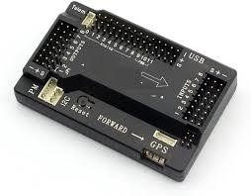
Figure 1.2 APM 2.8 Flight Controller
Key Features:
- Built-in ATMega2560 processor and ATMega32U2 USB interface.
- Onboard sensors include gyroscope, accelerometer, and barometer for motion detection and altitude measurement.
- Supports multiple flight modes: Manual, Stabilize, Altitude Hold, Loiter, and Return-to-Home.
- Compatible with GPS modules and telemetry systems for advanced navigation.
- Integrated PID control system for stable flight adjustment.
The APM 2.8 was selected because it is open-source, easy to configure using
Mission Planner software, and widely supported by the drone research community. It ensures flight stability even under windy conditions and provides a strong foundation for custom drone projects.

1.3 DJI F450 Quadcopter Frame
The DJI F450 frame serves as the main structural body of the drone. It is a lightweight yet strong quadcopter frame designed to carry all essential components such as the flight controller, ESCs, battery, and motors.
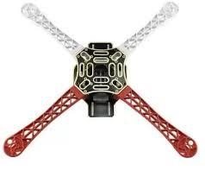
Figure 1.3 DJI450 Quadcopter Frame
Specifications:
- Wheelbase: 450 mm
- Material: Glass fiber and nylon composite
- Weight: Approximately 300–350 grams
- Configuration: X-type quadcopter layout
- Payload capacity: Up to 1.5 kg Features and Advantages:
- Built-in Power Distribution Board (PDB) simplifies wiring between ESCs and battery.
- The cross-type design provides excellent aerodynamic balance.
- Shock-resistant arms minimize vibration during flight.
- Ample space in the center for mounting electronics and wiring.
The DJI F450 frame was chosen for its stability, reliability, and ease of assembly, making it an ideal choice for research-based drone development.

1.4 900KV Brushless Motors (x4)
The drone uses four 900KV brushless DC motors that generate lift and provide directional control. Brushless motors are more efficient, durable, and powerful than brushed motors, making them ideal for quadcopter applications.

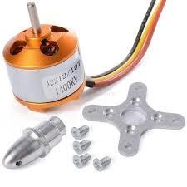
Technical Details:

- KV Rating: 900KV (900 RPM per volt applied)
- Operating Voltage: 7.4V – 14.8V
- Recommended Propellers: 10x4.5 inches Figure 1.4 9000Kv Brushless Motor
- Thrust Output: Approximately 850–950 grams per motor
- Motor Type: Out runner motor for high torque at lower RPM
Working Principle:
Each motor rotates a propeller that creates thrust through air displacement. The APM flight controller adjusts motor speeds to maintain balance and control pitch, yaw, and roll movements.
Advantages:
- High efficiency with minimal noise.
- Longer lifespan due to lack of friction-based brushes.
- Excellent torque control and smooth operation.

1.5 40A Electronic Speed Controllers (ESCs)
Each Electronic Speed Controller (ESC) connects one brushless motor to the flight controller and battery. The ESCs regulate how much power each motor receives, allowing the drone to ascend, descend, and maneuver accurately.

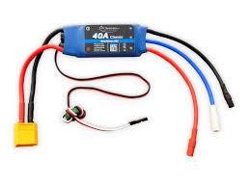
Figure 1.5 40A ESC
Specifications:
- Continuous Current: 40 Amperes
- Input Voltage: 2S–4S Li-Po (7.4V–14.8V)
- Built-in BEC: 5V/2A for powering flight controller
- Signal Input: PWM control from APM 2.8 Functions:
- Converts DC power from the Li-Po battery into three-phase AC current for brushless motors.
- Adjusts motor speed based on throttle signals.
- Provides overheat and overload protection to ensure safe operation.
The 40A rating ensures sufficient current delivery during high-load conditions such as takeoff and turns, reducing the risk of voltage drops or sudden shutdowns.

1.6 Li-Po Battery (2200mAh)
A 3-cell (3S) 11.1V 2200mAh Li-Po (Lithium Polymer) battery is used as the primary power source for the drone. Li-Po batteries are preferred for drones because they deliver high current output with minimal weight.
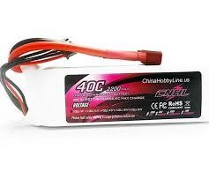

Specifications:
  - Capacity: 2200mAh
  - Voltage: 11.1V (3S)

  - Discharge Rate: 25C–35C
  - Weight: Approximately 180 grams Features: Figure 1.6 Li-Po battery (2200mAh)
  - Provides 12–15 minutes of flight time under normal payload.
  - High energy density for longer flights.
  - Requires balanced charging to maintain battery health.
  - Must not be discharged below 3.3V per cell to prevent damage.
The Li-Po battery was chosen for its lightweight construction and high efficiency, making it ideal for aerial applications that demand steady and reliable power.

1.7 FlySky FS-i6 Transmitter and Receiver
The FlySky FS-i6 transmitter and FS-iA6 receiver are used for wireless communication between the pilot and the drone. Operating on the 2.4 GHz frequency, this system ensures stable control with minimal interference.
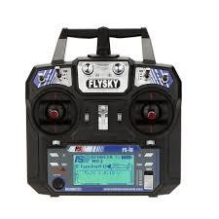
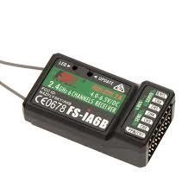
Figure 1.7 FlySky-FS i6
Specifications:
  - Channels: 6
  - Range: Up to 500–1000 meters (open area)
  - Operating Voltage: 4.8V – 6.0V
  - Modulation: AFHDS 2A (Automatic Frequency Hopping Digital System) Functions:
  - The transmitter sends control signals for throttle, yaw, pitch, and roll to the receiver.
  - The receiver forwards these signals to the APM flight controller, which adjusts the motor speeds accordingly.
  - Additional switches can be used to change flight modes.
Advantages:
  - Affordable and reliable for research projects.
  - Simple configuration with APM controller.
  - Good range and low signal delay for real-time control.

1.8 ESP32 Camera Module
The ESP32-CAM module is a compact camera integrated with an ESP32 microcontroller, capable of capturing and transmitting real-time video over Wi-Fi. It is mounted beneath the drone to capture live aerial footage of the land.
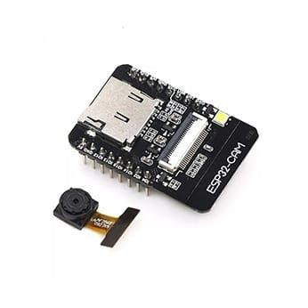
Specifications:
  - Camera: OV2640, 2MP resolution
  - Video Output: 640x480 / 800x600 / 1600x1200
  - Communication: Wi-Fi (2.4 GHz)
  - Processor: Dual-core ESP32
  - Storage: MicroSD card slot for recording images/videos
Figure 1.8 ESP32-Camera
Features: Module
  - Transmits video stream directly to a laptop or mobile device.
  - Compact and lightweight, making it suitable for drones.
  - Low power consumption and easy programming.
  - Can operate independently or integrate with the APM system.
The ESP32 camera enables live land monitoring without requiring expensive gimbal or FPV systems, making it ideal for barren land detection tasks.

1.9 Connectors
Connectors are used to link electrical components such as the battery, ESCs, and flight controller. Proper connectors ensure secure and reliable electrical connections that can handle high current flow without heating or power loss.
Types Used:
  - XT60 connectors for battery and ESC connections.
  - Servo connectors for signal wiring between ESCs and the APM.
  - JST connectors for small peripheral modules.
Importance:
  - Prevent accidental disconnection during flight.
  - Simplify component replacement and maintenance.
  - Maintain consistent voltage delivery throughout the system.

1.10 Holding Wires
Holding wires, also known as power and signal cables, connect all electrical parts of the drone. They transmit both current and control signals between components.
Features:
  - Silicone-insulated to withstand high temperatures.
  - Flexible to prevent wire breakage during vibration.
  - Color-coded for easy identification (red for positive, black for ground, yellow/white for signal).
Proper wire management minimizes interference, improves cooling, and enhances safety during flight.

1.11 Soldering Iron and Assembly Tools
A soldering iron is used to join electronic components permanently by melting solder wire to create a conductive path. In this project, a 60W temperaturecontrolled soldering iron was used to connect wires, ESCs, and connectors.
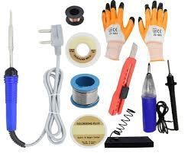
Supporting Tools:
  - Solder wire (60/40 tin-lead composition) for strong joints.
  - Flux paste to remove oxidation and improve solder flow.
  - Wire stripper and cutter for preparing connections. Figure 1.11 Assembly Tools
  - Heat shrink tubing for insulation and protection.
Importance:
  - Ensures durable and low-resistance connections.
  - Prevents voltage drops and electrical shorts.
  - Provides mechanical stability to all joints.
Proper soldering practices were followed to guarantee the reliability of all electrical connections in the drone’s circuitry.

1.12 Other Necessary Components
In addition to the main hardware components, several supporting parts were used during the construction and testing phase:
  - Propellers (10x4.5 inch): Provide lift and thrust for flight.
  - Power Distribution Board (PDB): Distributes power evenly from the Li-Po battery to ESCs.
  - Landing gear: Protects the drone and camera during takeoff and landing.
  - Battery strap and mount: Securely holds the Li-Po battery to the frame.
These accessories play a vital role in ensuring flight safety, balance, and maintenance ease.

1.13 Summary
This chapter presented a detailed overview of all the hardware components used in the construction of the Green Wings drone. The system consists of an APM 2.8 flight controller, DJI F450 frame, 900KV brushless motors, 40A ESCs, 2200mAh LiPo battery, FlySky FS-i6 transmitter/receiver, ESP32 camera, and other essential connectors and assembly tools.
Together, these components form a stable, efficient, and lightweight quadcopter capable of performing aerial monitoring tasks necessary for detecting barren land and supporting afforestation efforts. The careful selection and assembly of these components ensure the drone’s reliability, performance, and suitability for environmental research applications.

